- Watch the following video, and then answer the question below completely, making sure to reference your textbook. All resources should be correctly cited in APA format.

Video: Wild Child: The Story of Feral Children
https://www.youtube.com/watch?v=cymZq1VblU0

Characterize and reflect on some of the ways that heredity and environment interact to produce individual differences in development. Use examples from the video and information from your textbook to support your answer.

- Written assignment questions give you the opportunity to demonstrate a mastery of the material from the texts, additional resources, and discussions. In your answers, be sure that when you make reference to the words or ideas of another, you carefully cite your sources. Your answer to each question below should be between 150 and 300 words in length (a paragraph or two, but less than a page). [MO2, 3]
Written assignments such as this one do not require the use of the APA format. Instead, please answer each question in a separate section, and number your answers, to make it clear to your mentor which section is meant to answer which question. Any citations you make should, of course, conform to APA guidelines for citations/reference lists.
- Define Kantian deontology, and give an example. Why is deontology a moral principle?
- Define utilitarianism, and give an example. Why is utilitarianism a moral principle?
- Outline what Pullman calls the principle of respect for human dignity. What support does he give for this principle?
- Outline Decker’s argument that there are no universal ethical principles. Does that mean that anything is permissible?

- Write a 2-3 page, double-spaced paper that examines the basis of the central nervous system including nerve cells, events at the synapse, the blood-brain barrier, how certain drugs affect behavior, and ethical issues with animal research.
Answer the following questions:
- Study the structure of the blood-brain barrier and discuss why it is important.​ How do drugs such as heroin and cocaine pass through this barrier and why does heroin have a faster effect on the brain? What effects do these drugs have on neurons, specifically at the synapse, and how does this influence behavior? [MO1.6]
- Summarize in detail what is happening in the image, starting with the action potential in the presynaptic neuron, through the release of neurotransmitters, the inhibition or excitatory response of the postsynaptic neuron, and the reuptake of neurotransmitters. [MO1.5]
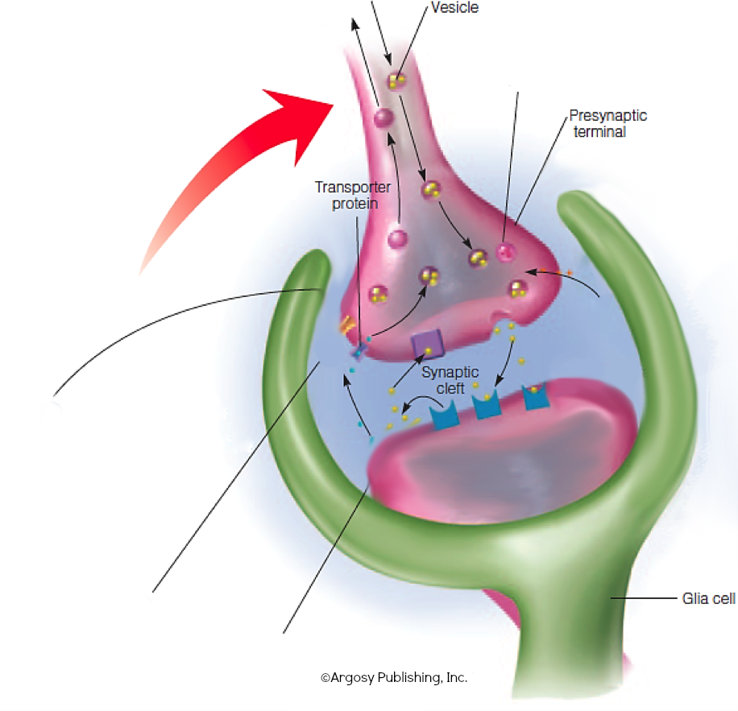
- Discuss action potential and the all-or-none law. Compare the function and process of the refractory period, including the relative and absolute refractory periods. [MO1.4]
- The glia cell (neuroglia) in the nervous system derived its name from the Greek name for “glue.” This term was given by early investigators who thought the main function of the cell was to hold neurons together. Given that glia have been shown to have several more functions in the nervous system, the original name of “glue” seems unfitting. What would be a better description for glia, given what we now know about them? Explain. Be sure to support your response with evidence from the text. [MO1.3]

- In a double-spaced, APA-formatted paper of 1000 to 1375 words (4 to 5 pages), thoroughly examine each of the following questions/topics. Be sure to properly cite and reference your sources whether from your textbook, supplemental sources, or other research. (Note: The entire assignment (as a whole) should be between 1000 and 1375 words, not each individual answer.)
All written assignments should be well organized and well written with correct grammar, word choice, punctuation, and spelling. Your writing should be clear and coherent. When you have utilized the thoughts or words of others, you must either paraphrase or quote directly and document the source in proper APA format.
- Define ethics and morals. Identify and describe the differences and similarities between ethics and morals.
- Conduct a self-assessment concerning your ethical development and ethical identity. Explain in reasonable detail where you are and how you come to making ethical decisions.
- Critically assess Festinger’s social comparison theory and how his theory is appropriate to ethical decision making.
- Identify and critically assess two rules that govern your behavior. What aspects of the two rules provide you with a compass to point you in the right direction? What are the strengths and limitations of your rules?
- Select and describe your favorite philosophical school. Describe why you selected this philosophical school over others. Explain how the school of thought shapes your ethical decision-making model (e.g., Kantian, Utilitarian, Socratic, Aristotelian, Critical Social Theory, Postmodern). [MO1.1, MO1.2]

